ODIN
ExLibris – Aleph500

Basic Information for downloading Aleph Version 22 client

Download Aleph software -- http://www.odin.nodak.edu.

- If you have previously installed Aleph version 22, uninstall it.
  - This is accomplished by clicking Start | Programs | Aleph 500 PROD v22 | Uninstall (the program name may include your library code).
  - Follow the default instructions for Automatic uninstall.

- Create the folder c:\inst500_v22 on your hard drive.

- Go to http://www.odin.nodak.edu. After logging into the site, go to the left menu list and in the ‘Your Library’ section, select Downloads. Note the version 22 client for both PROD and TEST can be found in the V22 Client (TEST) section. Right click on the link for the client you wish to download.

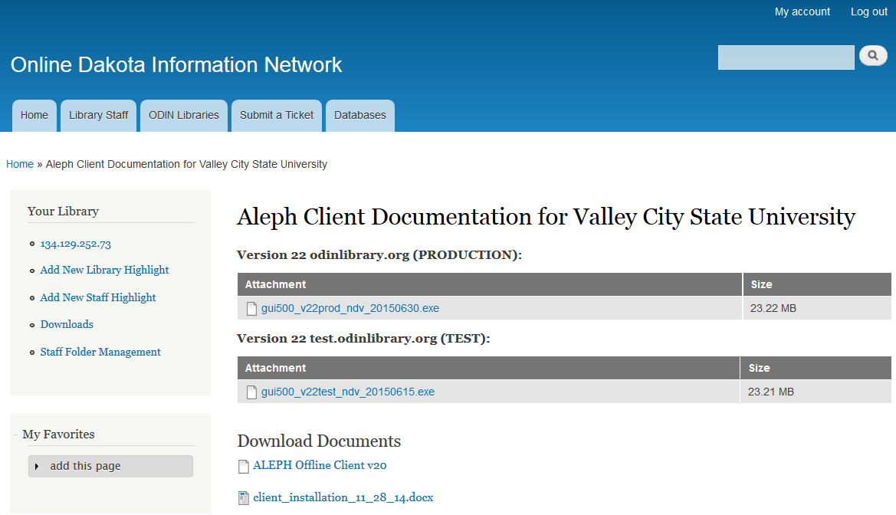

- Right clicking on the link presents a menu box. Depending on the browser you are using wording may be different, but select the save option.

Firefox:
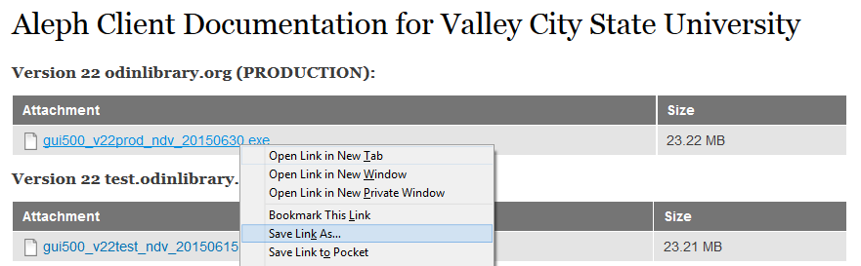

Explorer:
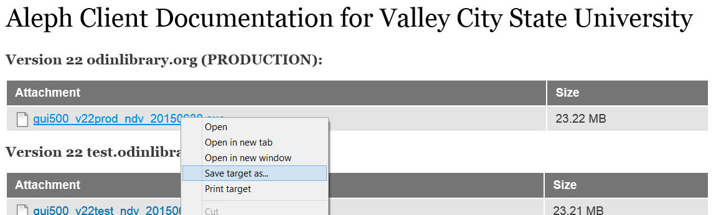

- Save the file to the inst500_v22 folder created in step two.

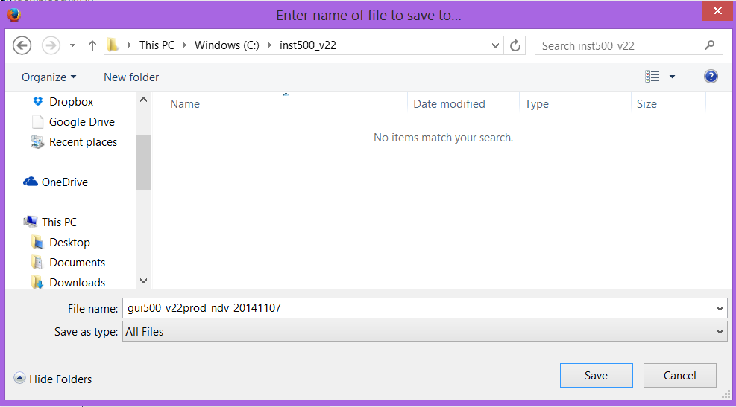

- Locate and open the inst500_v22 folder on your computer. In this folder, you should see a GUI.exe file. Double click on this file.
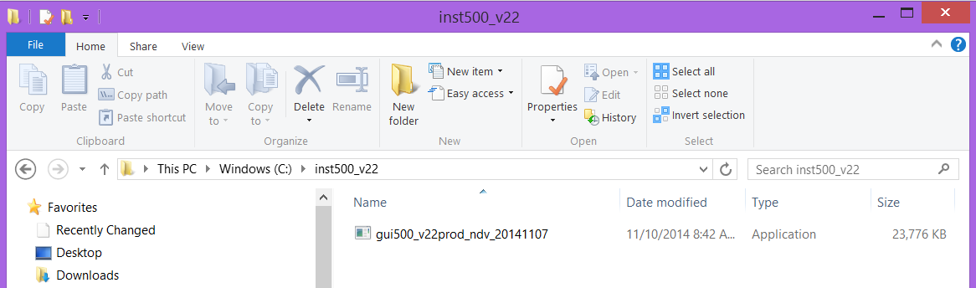

- An Open File box may appear. Click Run, and a black DOS window will pop up and extract the files. Some systems are not configured to display an Open File box, rather the files just automatically extract.

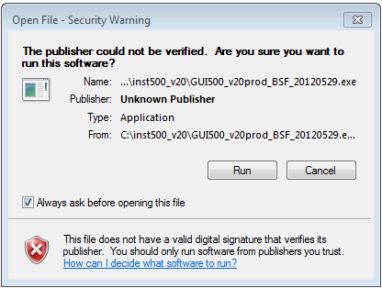

Window 8 may present a message indicating the application is unrecognized. Click ‘More info’ and then ‘Run Anyway.’

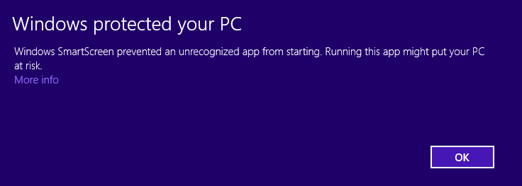

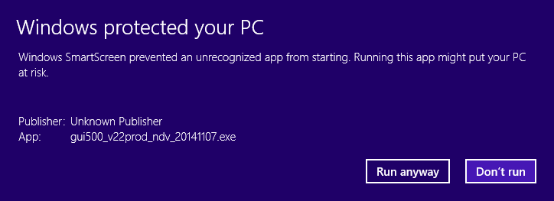

- Once the files have been extracted, double click on the setup.exe file.

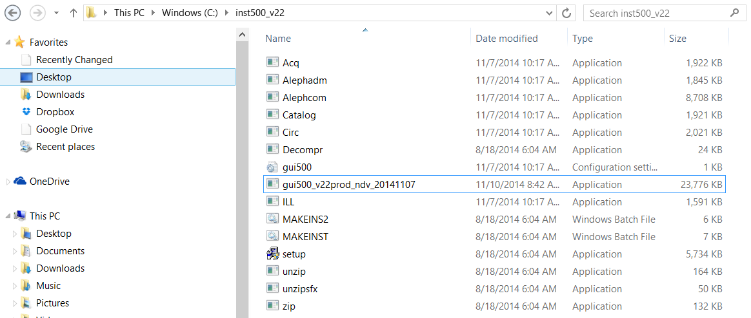

- You will be taken through the setup wizard. Select all the defaults. You will notice that the client will be installed in an ALEPH 500 XXX PROD V22 directory, where XXX is your three letter code.

- To login to the client, go to your computer’s Start Menu | All Programs | ALEPH 500 XXX PROD V22 (where XXX is your three letter code) and select the module you wish to login to. Version Checks are conducted at the time the modules are started. (The program name may be followed by your library code). IF prompted with new files, on the Version Check box be sure to select ‘Update All’ to install the new files to your computer. After the files have been installed, ALEPH will ask you to relogin to the module.

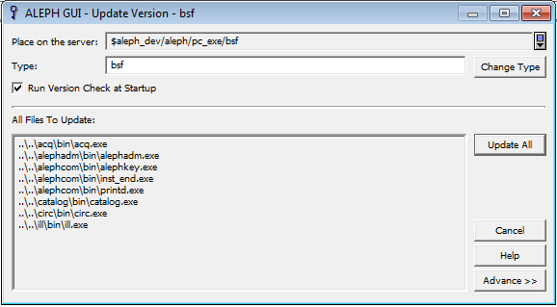

Windows 8 users can access the client via the Apps menu or via the C: drive (note: accessing the client via the C: drive is available to users on any platform).

Apps menu:

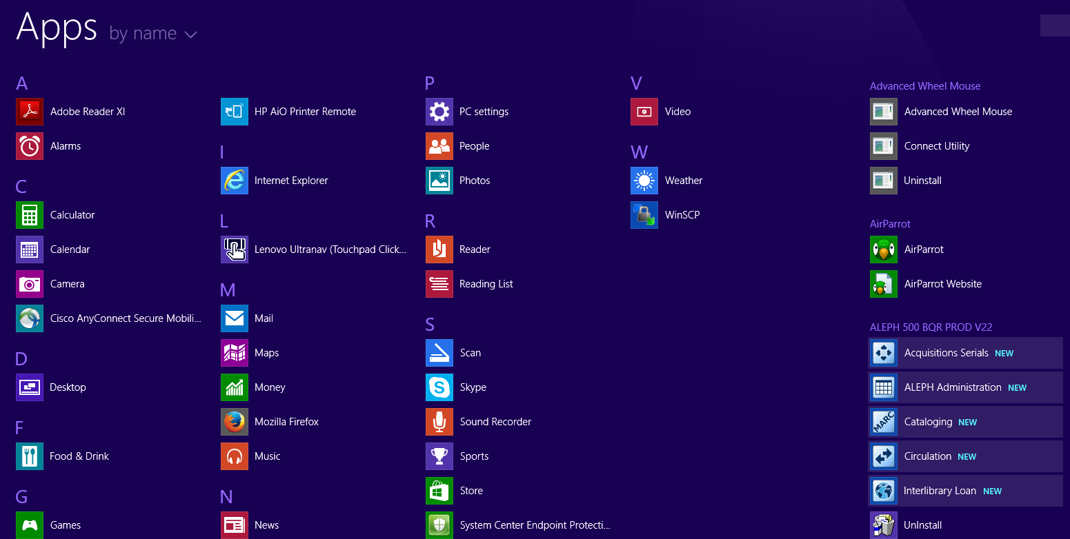

C: drive – Go to the AL500 XXX PROD V22 folder, select the module folder (Circ, ILL, etc.), select the BIN folder, and double click on the file.

