How to add a local extension field to a bibliographic record

Adding a local extension field to a bibliographic record will:
- Make that field only visible to the owning library
- Protect the field from being over-written by newly imported records
Starting with the record open in the Metadata Editor, click the menu “Editing Actions” and then select “Add Local Extension.”
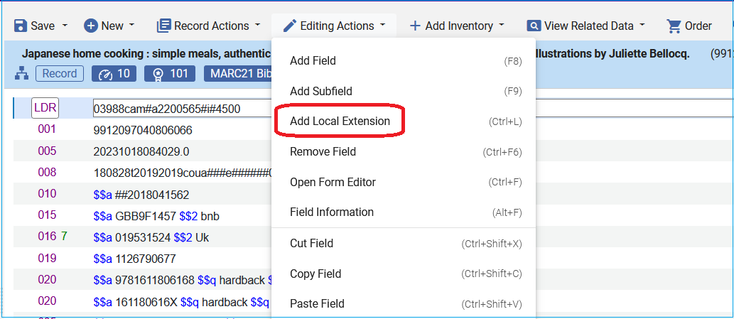
A blank field with the local extension “building symbol” will appear.
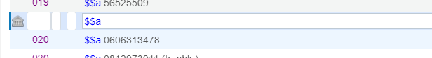
Fill in the field information:
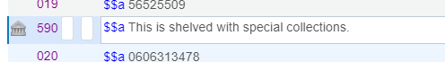
Save the record. By saving the record, the field will be sorted into its proper place in the record.
Note: Local extension fields generally have a “9” in them. For example: 590, 691, 900.
Here is a full list of local extension fields for ODIN libraries.

