How to extract OCLC numbers from a file of MMS IDs and batch delete holdings in OCLC
Part 1. Gather the MMS IDs
Starting with a set of Titles in Alma, either view results or members of the set:
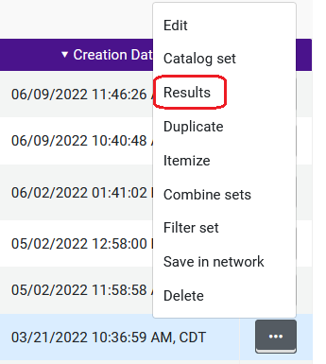
Then click on the export list icon:
Select “Current View.” This will export the list as an Excel spreadsheet. The spreadsheet will download onto your computer.
Part 2. Use Analytics to collect the OCLC numbers
In Analytics, click Create, Analysis. Select the “Titles” subject area.
In the Bibliographic Details folder double click MMS ID to add it to the criteria for the report.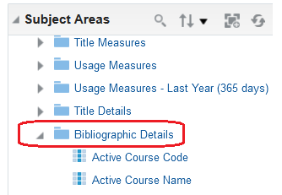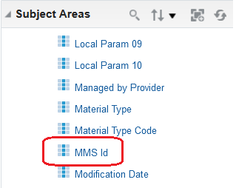
From the Bibliographic ID’s folder double-click OCLC Control Number single (035a) to add it to the report criteria.
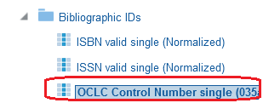
Add a filter to the MMS ID column by clicking on the cog icon and selecting Filter:
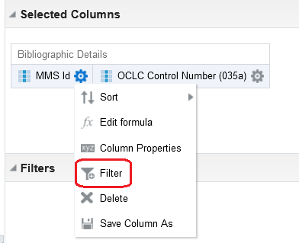
Click the Value drop-down arrow:
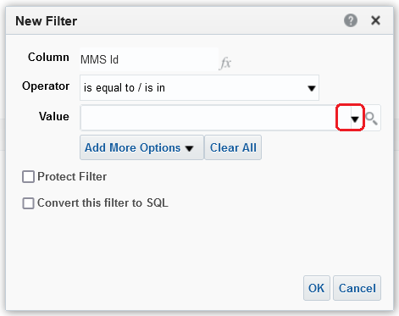
Click on More/Search:
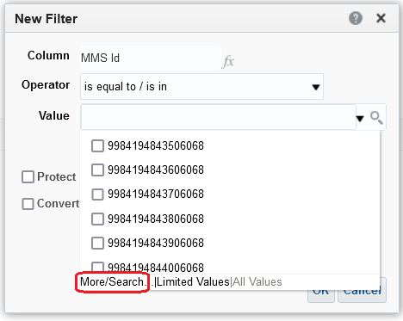
Click on the Edit icon:
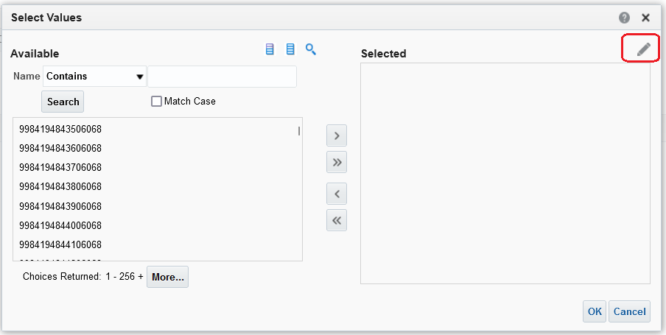
Open the spreadsheet that you downloaded in part 1 and scroll to the right until you see the MMS ID column. Highlight and copy all the MMS IDs in the column. Paste the MMS IDs into the Edit box and click OK.
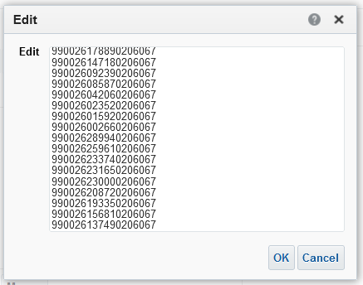
Click OK until all the boxes close.
Save the report by clicking on the save icon and give the report a name.
Click on the results tab, and the report appears.
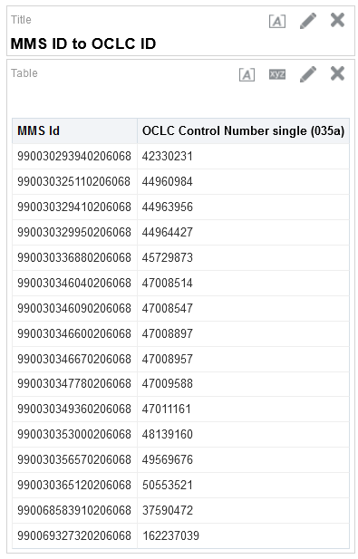
To export the report to an Excel spreadsheet, click on the icon to export the report to your computer.
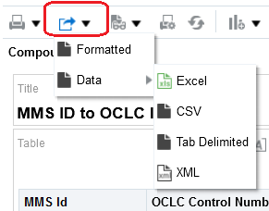
Part 3. In Connexion use the OCLC numbers to delete holdings
In Connexion, you can use this file of OCLC numbers to delete holdings in batch.
Click the Batch menu and select Holdings by OCLC number:
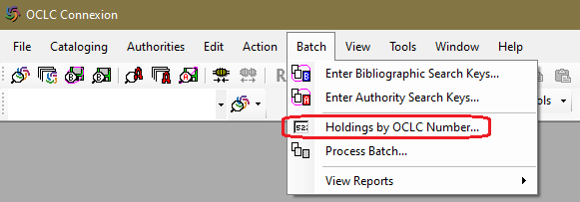
Copy the column of OCLC numbers from the excel report and paste them into Connexion.
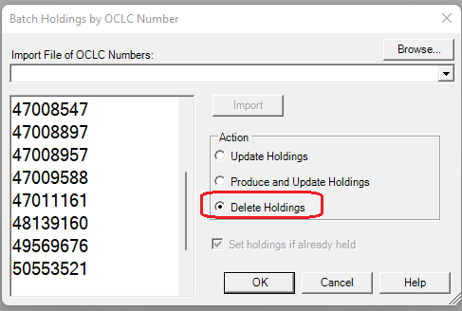
Select Delete Holdings and click OK.

