**Patrons reporting PLACE REQUEST option not displaying**

If patrons report not seeing PLACE REQUEST option next to an item in their search results, they are likely in the "ODIN View" instead of their home library’s view. Example below uses Grand Forks Public as the home library.

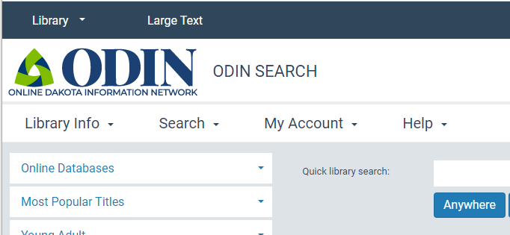     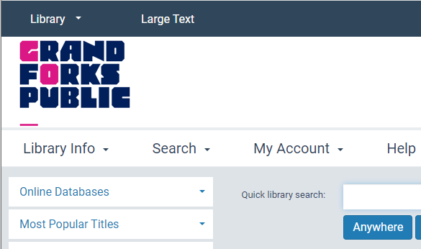

The best URL for a patron to sign in and start a search/request process is their home library view but sometimes patrons that have found their way into the ODIN view. To get to their home library from the ODIN view, they can use the Library dropdown in the upper left corner to select correct library:

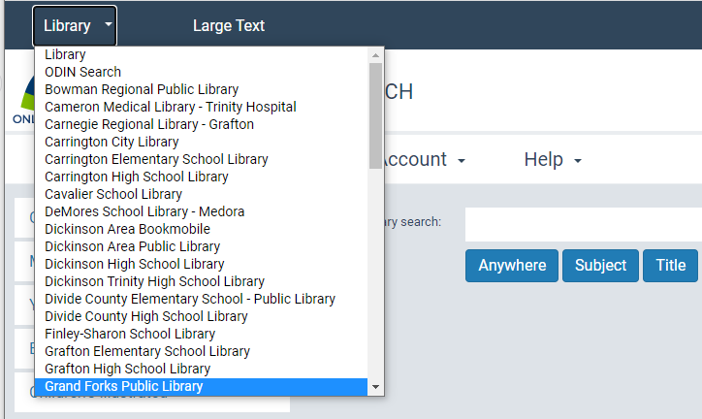

If the patron does not find what they are looking for in their home library, they can check holdings from other libraries in the state by clicking on All ODIN Libraries in the Expand your Search dropdown:

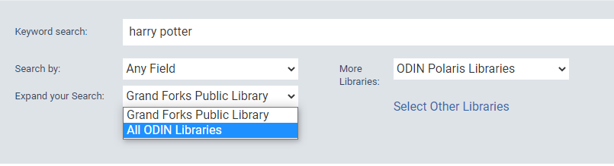

When patrons are logged into their home library, the PLACE REQUEST option should be available.  If they have further questions or problems, they can choose Ask Us under the Library Info dropdown while in their home library to see a form that will be routed to the email address or URL configured for the AskUs requests.

