Resource Sharing User Group Meeting Agenda
Wednesday, December 29th, 2021
- Updates
  - 2022-2023 Chair = Joan Miller
  - Don’t forget to update your Alma calendars for 2022!
  - NBJ has been configured for direct Resource Sharing w/ Minitex
  - Nothing of note in January 2022 Release notes
  - Library updates

- Automatic Locate
  - Lending Requests are set to match on Title, ISBN/ISSN, OCLC Number, & LCCN
  - If these fields are missing from a Borrowing Request, Alma can only match on the info available, generally from the Title field.
  - Rules can be set to prevent Borrowing Requests from being sent automatically if they are missing required fields
    - Sending Borrowing Request rules (Missing metadata)

- 2022 meetings will occur every other month. Does the last Wednesday of the month at 9am still work for everyone?

- Anything else you would like to discuss or address?

- Next meeting is scheduled for February 23rd, 2022 via TEAMS

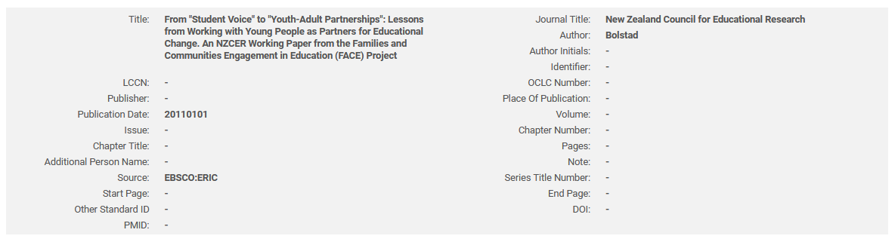
Borrowing Request

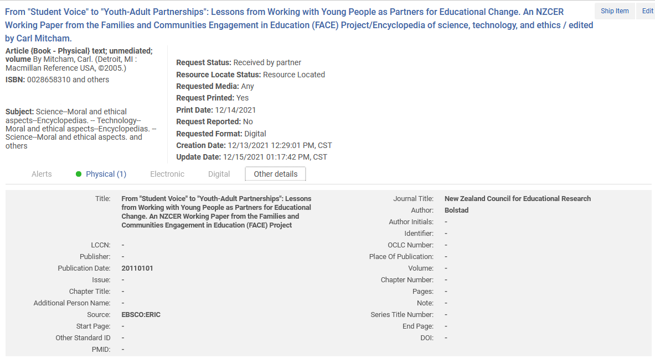
Lending Request

