Polaris LEAP Cataloging
Copy Cataloging - Adding a Bib Record from Template

Before adding a record from a template, be certain to first check the ODIN Polaris database as well as other sources (such as Worldcat or ODIN Academic libraries) to assure a record doesn’t exist in the Polaris system or in another system in order to copy.

- After logging into Leap, go to New | Bibliographic Record
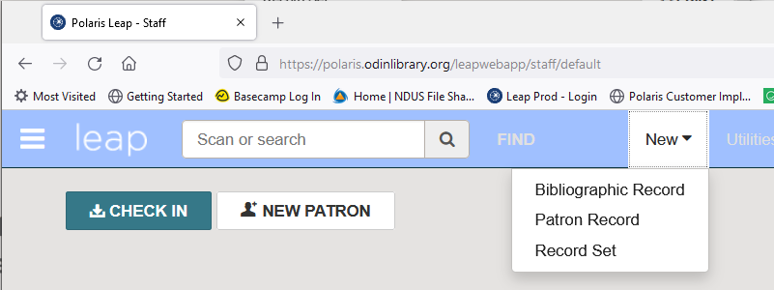

- From the drop-down menu, select the bib template that most resembles the type of material in hand.

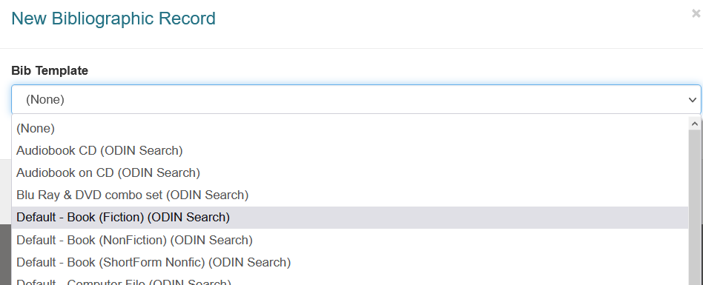

- Once the template has been selected, a blank bibliographic record appears on the screen. Fill out the fields needed, and delete the fields not utilized. To edit a field, select the check-box next to it and click Edit Tag.

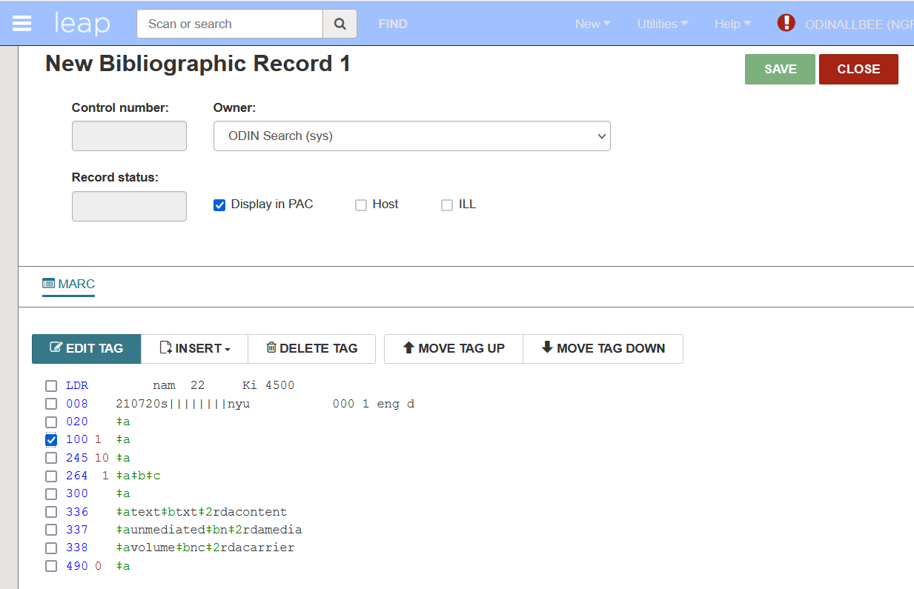

- A workform appears allowing you to enter information into the field. After entering information, click OK.

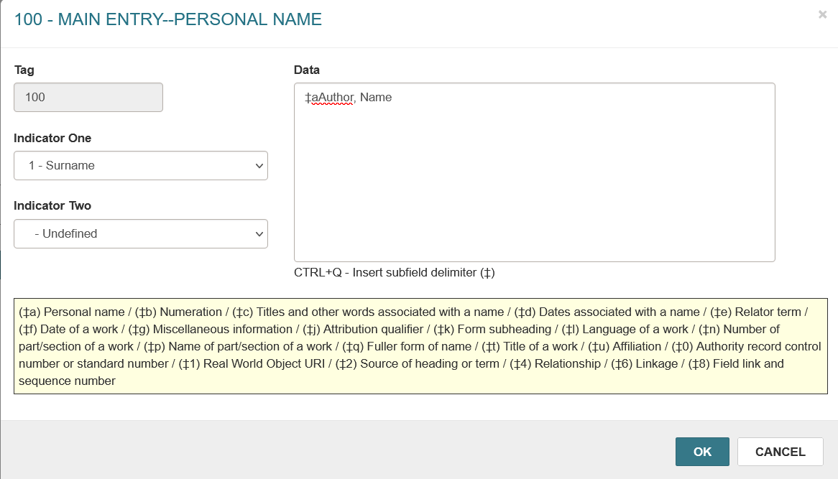

- Continue selecting fields and entering information as appropriate. If there are fields that will not be used, select them and click Delete Tag. Any empty tags that are not deleted will present an error upon saving the record.

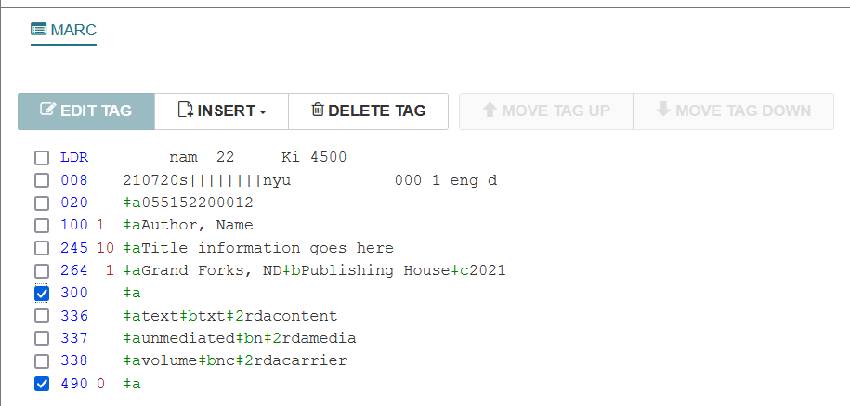

- After completing the fields in the record, click Save to save it to the Polaris database.

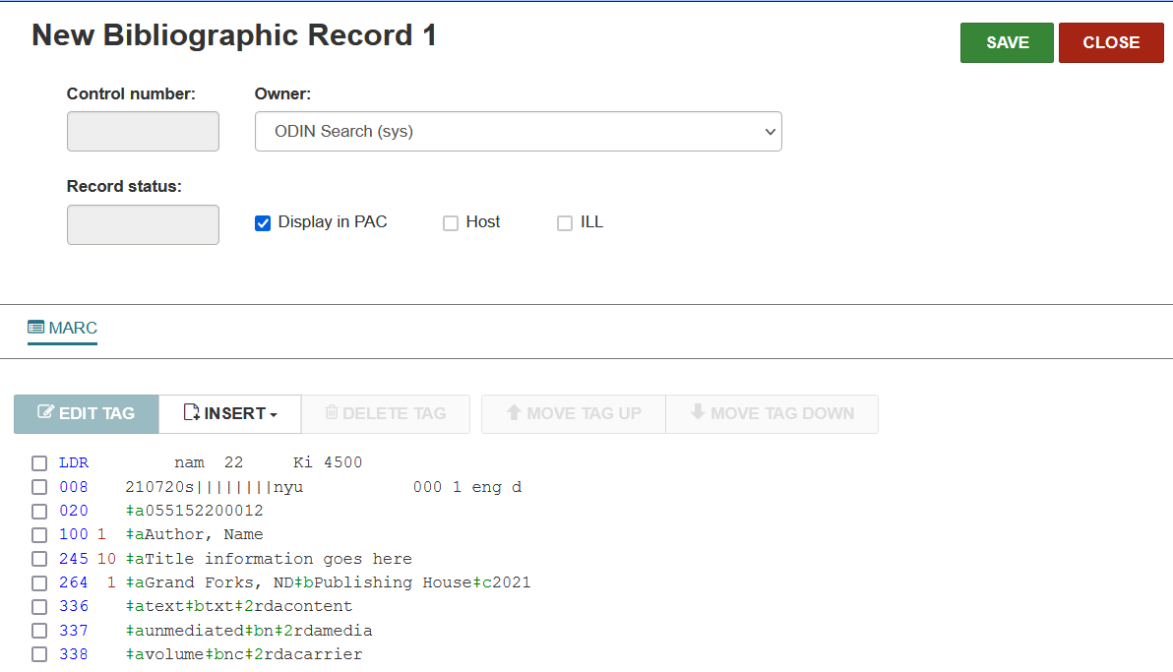

- Once the record is saved, a control number is assigned. At this point, you are able to add an item record to the bib. Please refer to the ‘add an item’ documentation for that process.

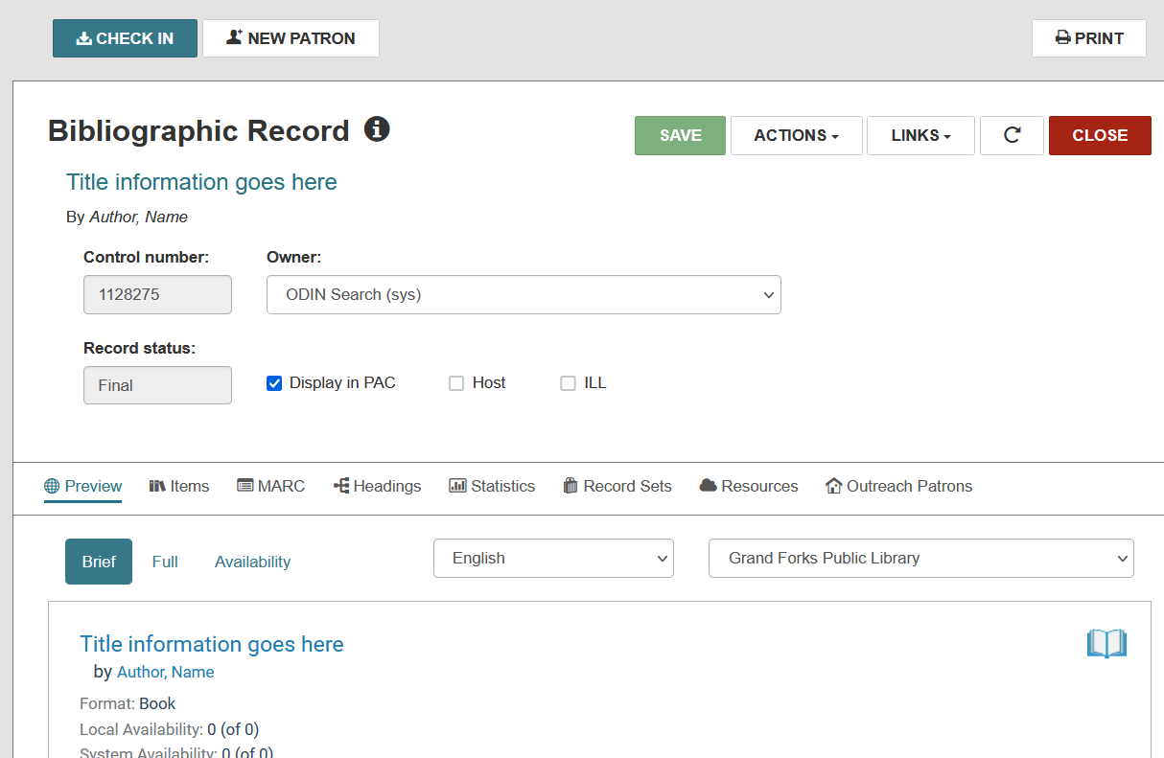

**NOTE: Depending on the template selected, the fields may differ. Two examples shown are for a fiction book and a DVD.

Default Book (Fiction):
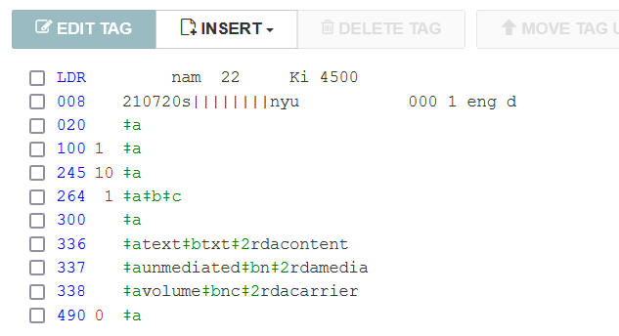

  - LDR – do not modify
  - 008 – do not modify
  - 020 – Enter the ISBN
  - 100 – Enter the author in format Lastname, Firstname
  - 245 – Enter the title
  - 264 – a - Enter the publication place, b – enter the publisher, c – enter the publication date.
  - 300 – Delete
  - 336 – do not modify
  - 337 – do not modify
  - 338 – do not modify
  - 490 – Enter the series if applicable or delete

Default – Video Recording (DVD):

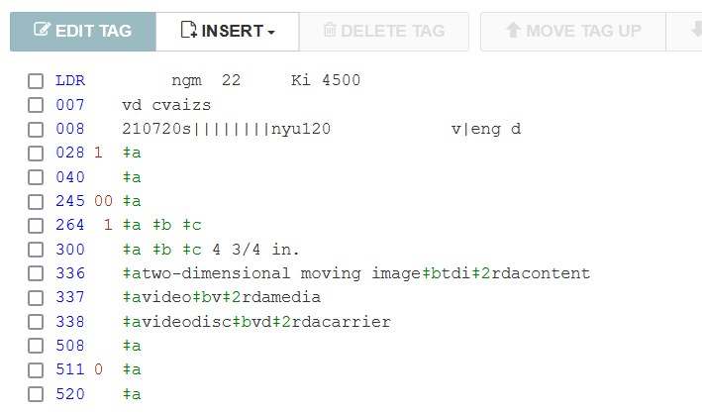

- LDR – do not modify
- 007 – do not modify
- 008 – do not modify
- 028 – enter publisher or distribution number if available or delete
- 040 - Delete
- 245 – Enter the title
- 264 – a - Enter the publication place, b – enter the publisher, c – enter the publication date.
- 300 – Delete
- 336 – do not modify
- 337 – do not modify
- 338 – do not modify
- 508 - Delete
- 511 - Delete
- 520 - Delete

