Labels 101
If you want labels set up for your branch, ODIN will ask you some administrative questions.
Every branch has a profile, and we will set up labels in the profile:
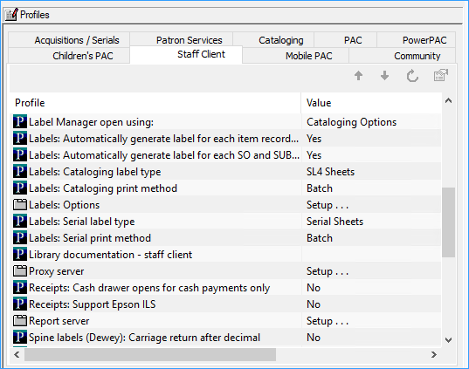
Label Type: What type of labels are you using for books, what type of label are you using for serials?
Printing method:
On Demand: the Label Manager appears when the user requests a label and the user can view the label before printing it.
Batch: the label is generated but it is not printed until the user opens the Label Manager and selects Print.
Quick Print: the label is printed at the designated printer without opening the label manager
Do you want a line break after the decimal in Dewey call numbers?

Label Manager
Click on Utilities, then Label Manager.
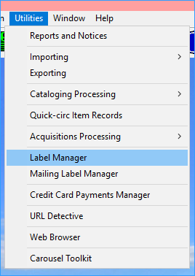
It opens up showing your batched labels. Here you can edit the labels. By right-clicking you can copy, paste, delete, change the font, and insert diacritics. (Insert the diacritics after the letter you want them to print above).
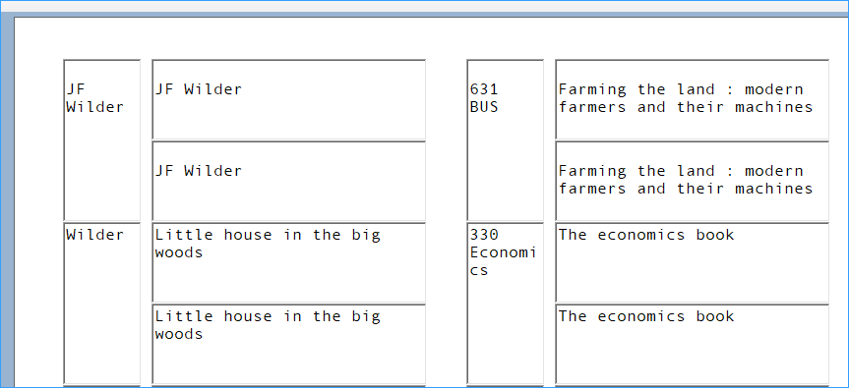
The Tools menu gives you options to edit label settings and content, to design a custom label, and you can set up different printers.
Use the Edit Label Settings to adjust where the text falls on your label, for example your text may be too close to the left edge of a label. This is the settings tab (below).
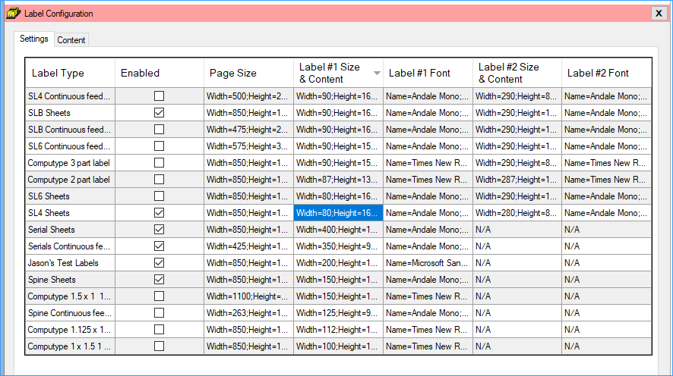
- Find the type of label you want to edit, and in that row go to the Label #1 Size and Content column.
- Right click in that box.
- The Label Details box appears and you can increase the label indent by typing a number in the indent field. Each number is 1/100 of an inch.
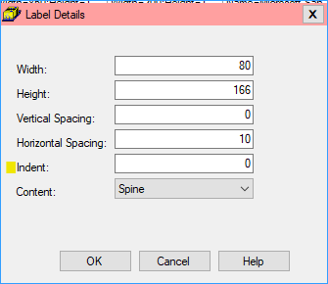
Notes:
Label #1 is the spine label, and Label #2 is the pocket label.
These settings affect the entire sheet of labels.
These settings may be different for different printers.
On the Content tab, (see below) you can select which fields you want to appear on your labels.
