Alma Resource Sharing
Returning an Item

- To return items that have been requested by your library through resource sharing, go to Fulfillment | Checkout/Checkin | Return Items. Items requested via ILL are returned in the same method as any other item loaned at your library.
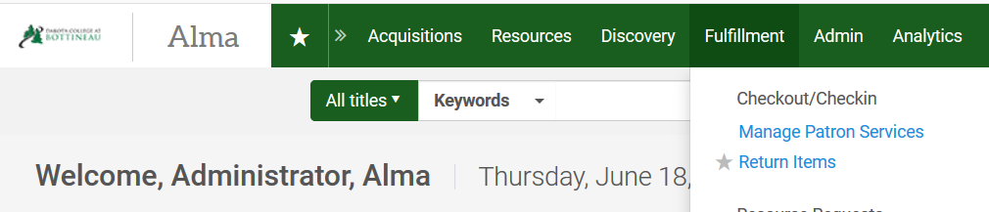

- On the Manage Item Returns screen, scan in the item barcode. A popup displays indicating where the item should be returned.
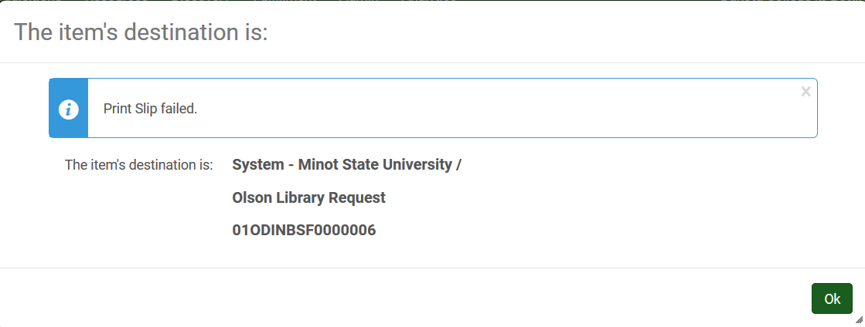
Additionally, on the return screen Alma indicates what the next step is, indicating what library the material should be returned to.
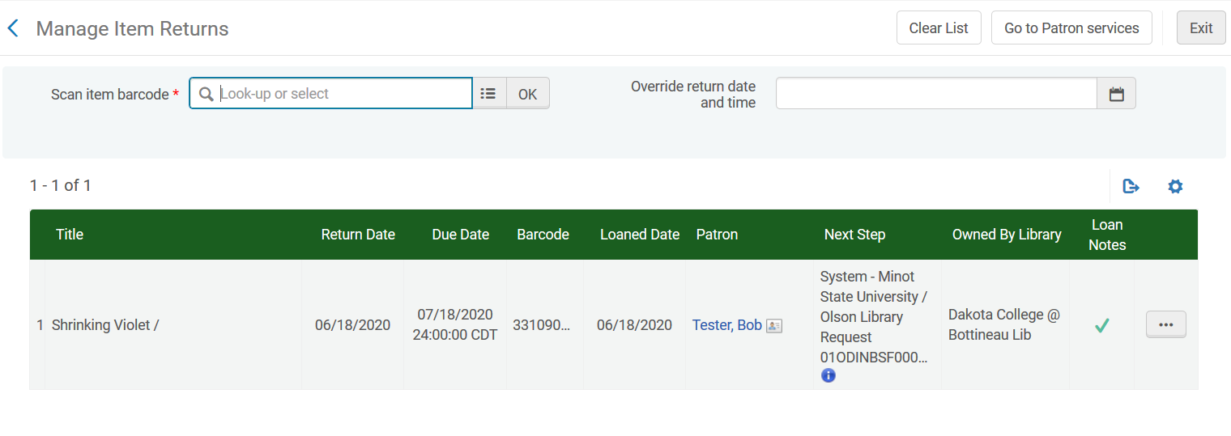
- Alternatively, you may retrieve the item by going to the Fulfillment menu and selecting Resource Sharing | Borrowing Requests. With the request on the screen, use the ellipse button next to the request and select Return.
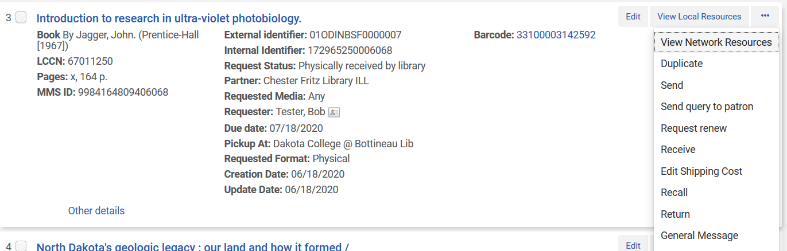

- A workform is displayed indicating where the item should be returned to, as well as options to print a slip and include an internal note or a note to the partner. Click OK to continue.
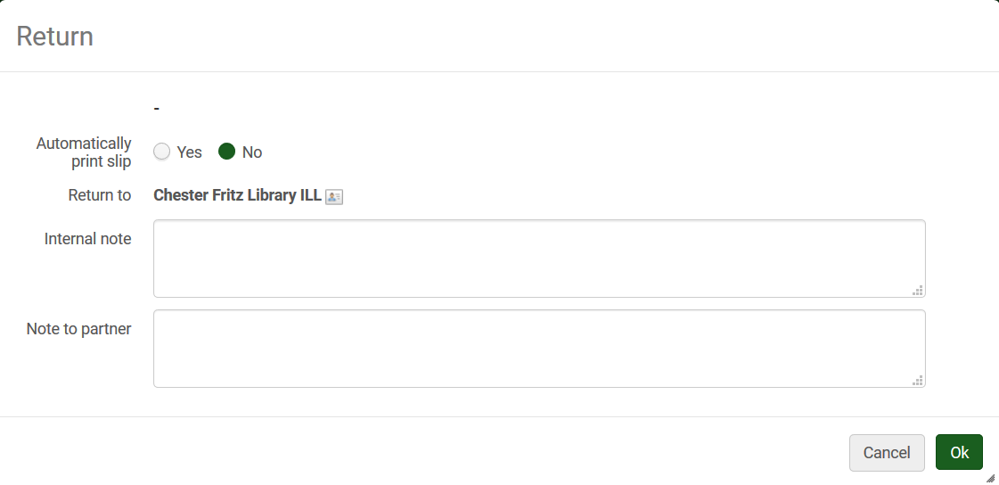

- In either method, the item is checked in on the patron’s record and the status of the request is updated to Returned item to partner.

