Alma Resource Sharing
Borrowing an Item

- Submitting Requests

- Resource sharing requests can be placed by patrons in Primo. After conducting a search, the patron has the ability to place a request on material.
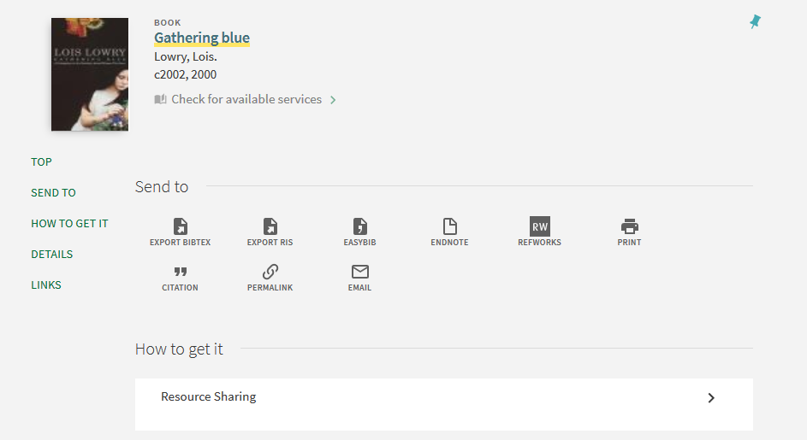

The patron receives a workform prepopulated with bibliographic data where they can complete individual information and click Submit.
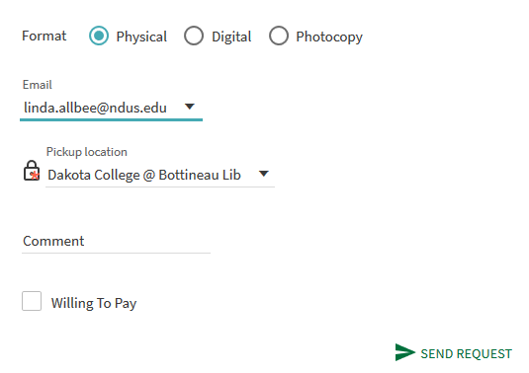
- Alternatively, staff may place a request on a physical item on the patron’s behalf. To do so, go to the Fulfillment tab and select Resource Sharing | Borrowing Requests.
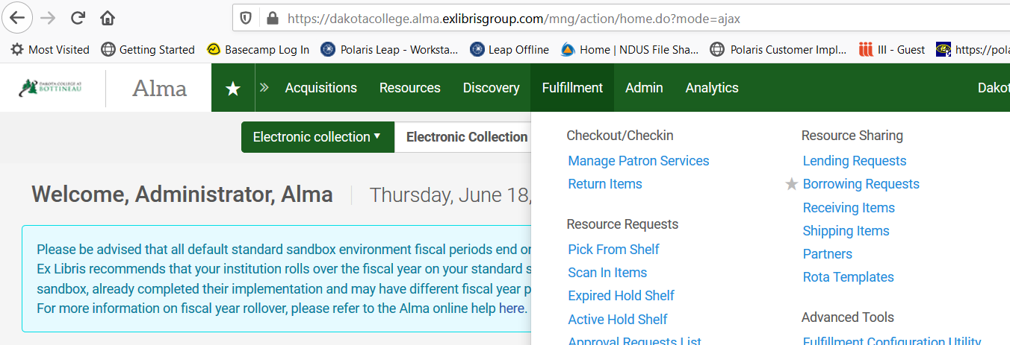

- The Resource Sharing Borrowing Requests page is displayed. Borrowing requests, plus facets to work with the requests, are displayed. To create a new request, select +Add and choose if you wish to add a manual request, a request from a search or a request by searching an external source. In this example we will add a request from search.
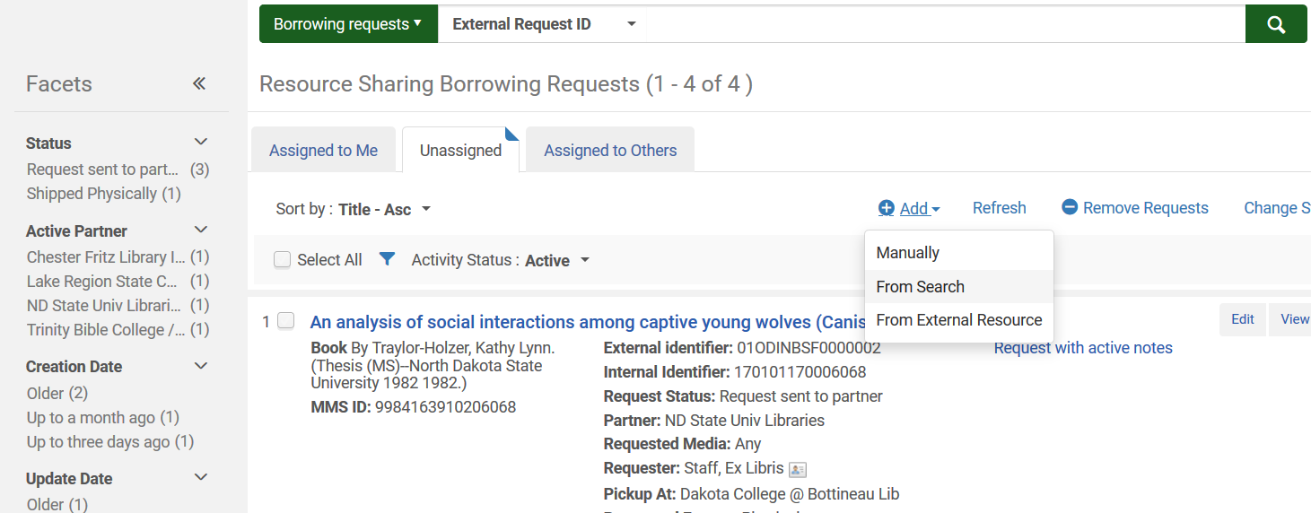

- Conduct your search using the network zone.
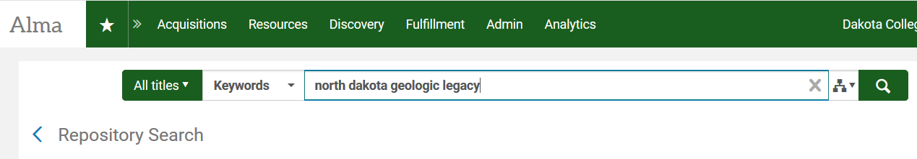

- When you locate the item you wish to order, click the radio button next to it and click Select.
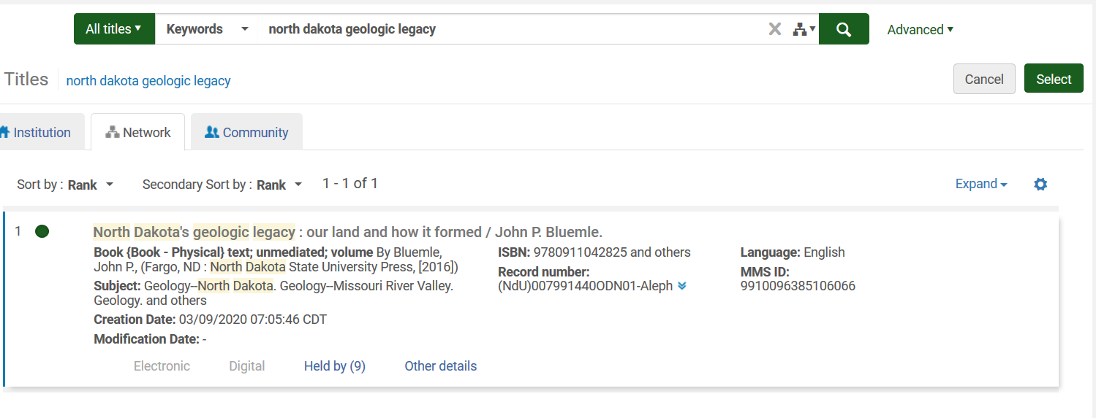
- A request form displays, populated with information from the selected bibliographic record. Fill out additional fields where necessary. When finished click Save or Save and Edit. Save and Edit leaves the request open for processing. In either case, the rota is automatically applied to the request, and it is sent to the first owning library in the list. If you no longer wish to pursue the request, click Cancel.

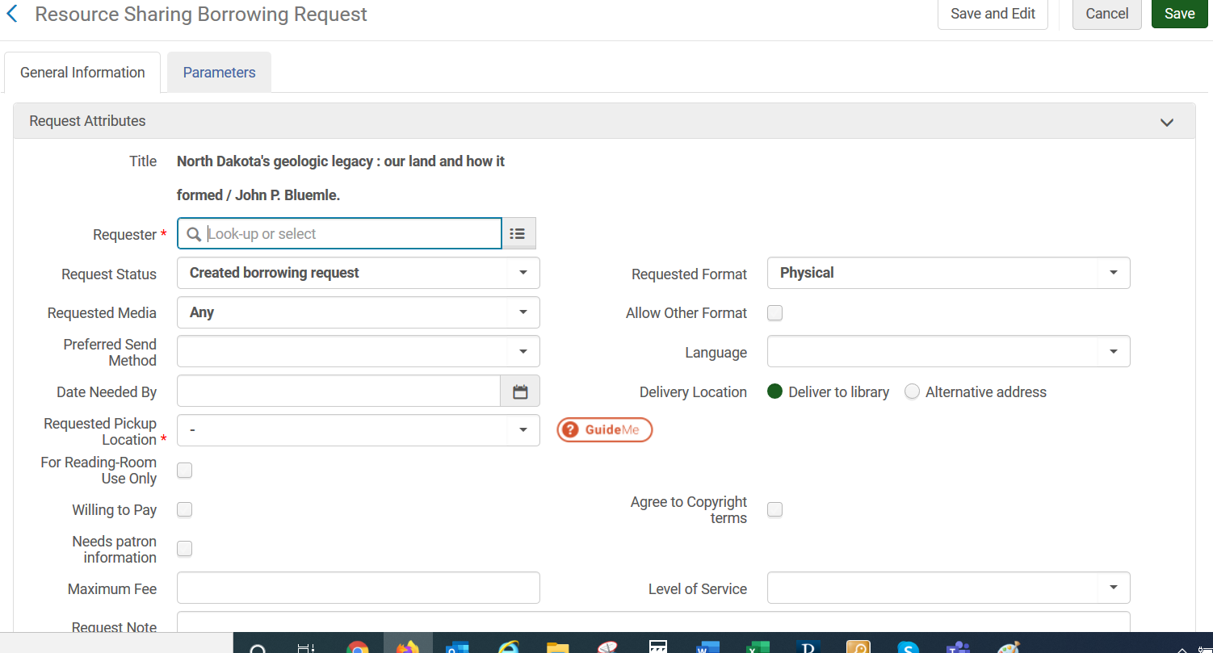
- Title – Information from the bibliographic record populates this field
- Requester (required) – Enter information to locate the patron requesting the material (name or identifier). When this field is populated, Alma will add the Owner of the patron record to the request.
- Request Status – Default to Created borrowing request
- Request Format – Defaults to Physical
- Requested Media – Select the type of material (such as book, dvd) that the patron is requesting
- Allow Other Format – Check this box if other formats are acceptable for fulfillment
- Preferred Send Method – Select the method the lender should use to send the material (such as mail)
- Language – enter language if desired
- Date Needed By – enter that last date the patron can use the material
- Delivery Location – defaults to deliver to library
- Requested Pickup Location (Required) – select the pickup location from the drop-down menu
- For Reading Room Use Only – check if the material will be used within the library only
- Willing to pay – check if the patron is willing to pay a fee
- Needs Patron information –
- Agree To copyright terms – check if a copy is being requested and it complies to copyright
- Maximum Fee – if patron is willing to pay, enter the maximum fee acceptable
- Level of Service – select level of service if desired (normal, rush, etc.)
- Request Note – enter any applicable notes if desired
- Add Partners / Add Rotas – you have the ability to manually add suppliers or a rota to the request. This can be skipped and Alma will automatically add suppliers to the request.
- Request Costs – these fields are not used in creating the borrowing request.

- Reviewing/Editing Requests
When viewing the request, there are several tabs that can be viewed or edited. Those tabs with a folded corner indicate there is information in the tab. The exception is the General Information tab.
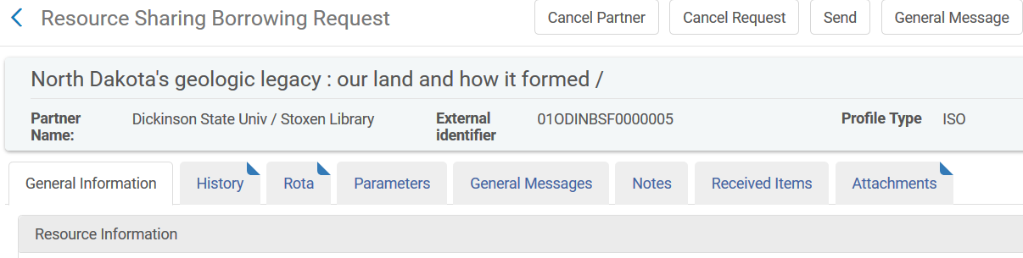

- General Information. This tab contains information about the request such as bibliographic information and request details. Fields can be edited if necessary.
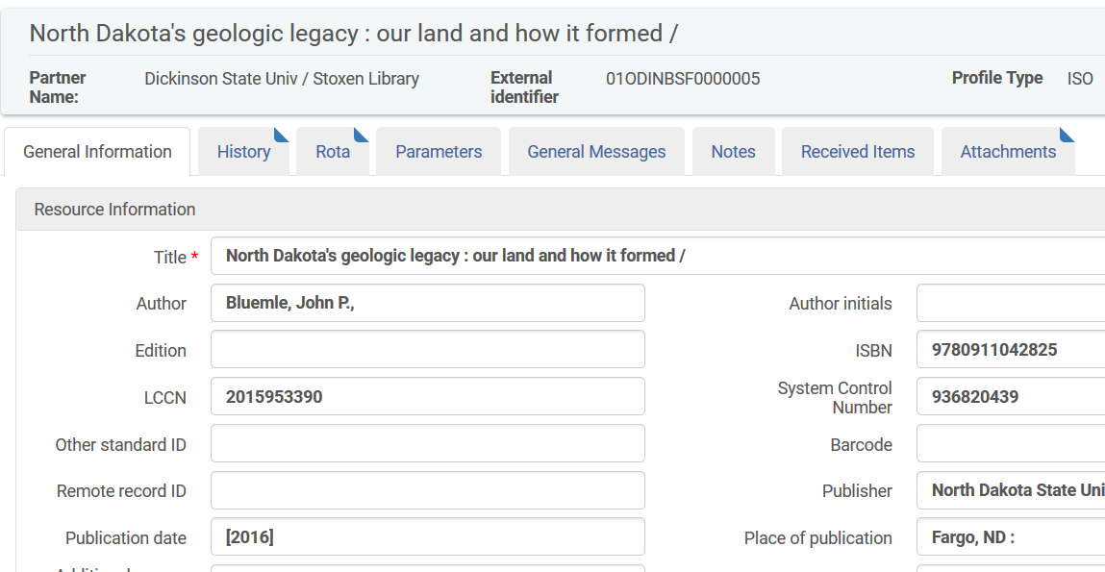

- History. This tab shows an audit trail of the request.
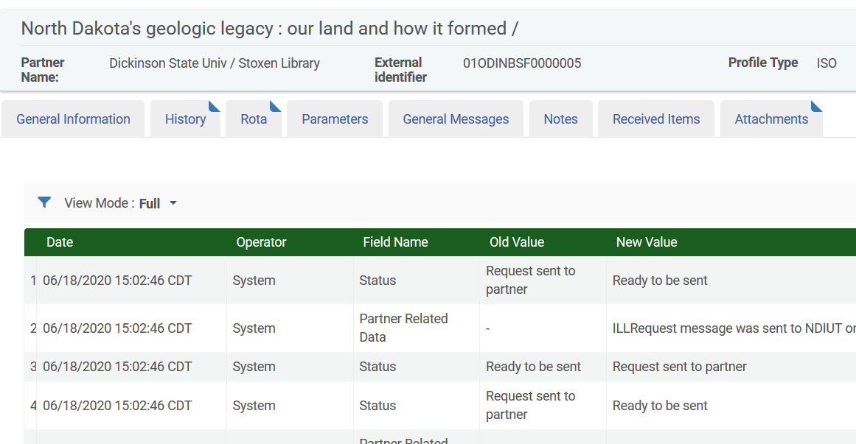

- Rota. This tab shows the list of suppliers that is being used. Here you are able to see which library the request has been sent to.
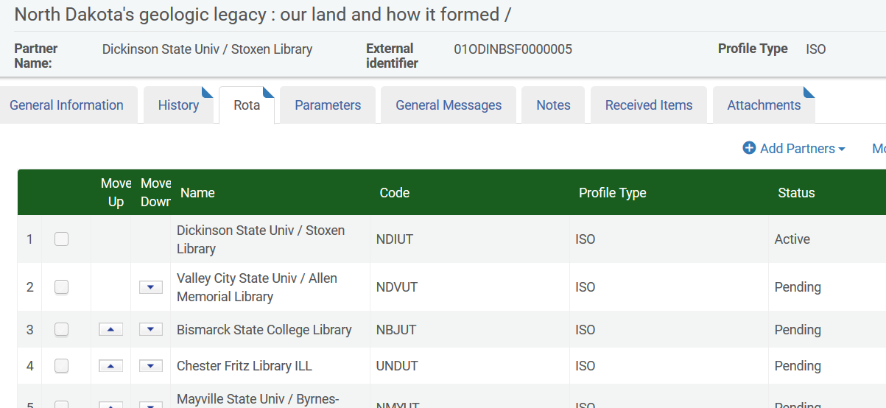

You are able to use the up and down arrows to rearrange the rota if necessary. Alternatively, select the radio button next to the library to be moved and click Move Selected to put them in a different spot.
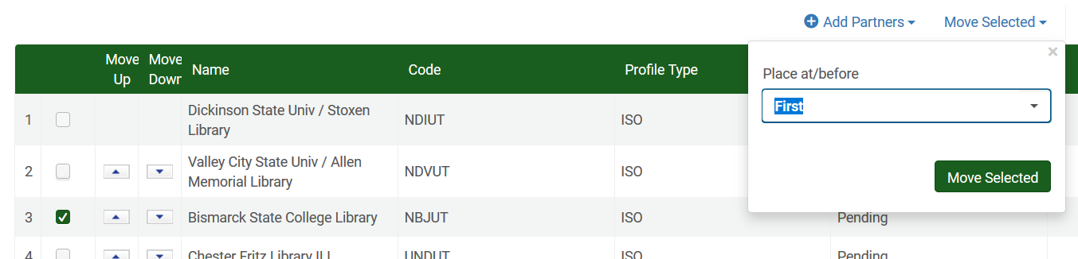

You can add a supplier not in the rota by clicking + Add Partners and selecting the library from the list.
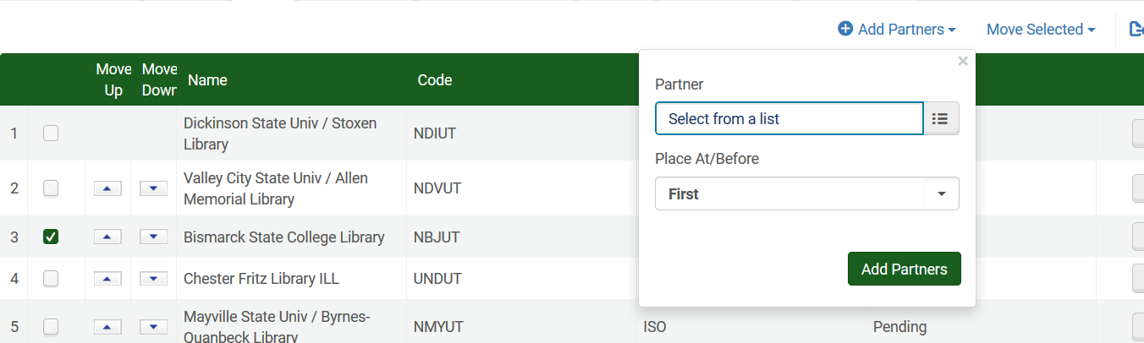
You are able to delete a partner from the rota by using the ellipse button next to the partners name. If the status is pending, you will only see the option to remove the partner.
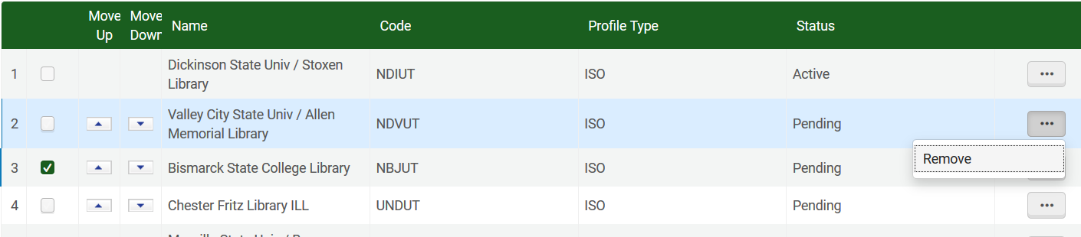
If you are attempting to remove the active partner, a Rejection or Cancelation must be conducted. Additionally, the request to the active lender can be initiated by clicking the Cancel Partner button.

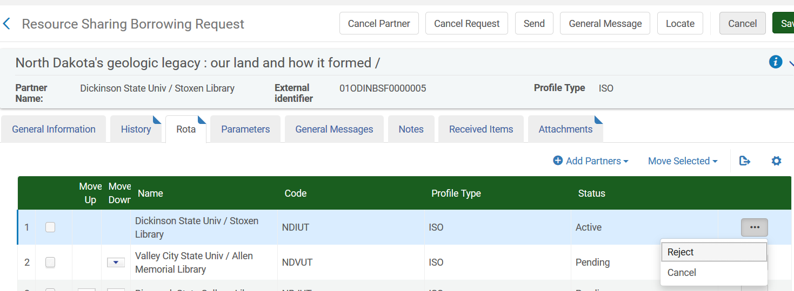
**Note: if you make changes to the rota, especially in regard to the active supplier. It may be necessary to conduct a manual locate and resend the request.
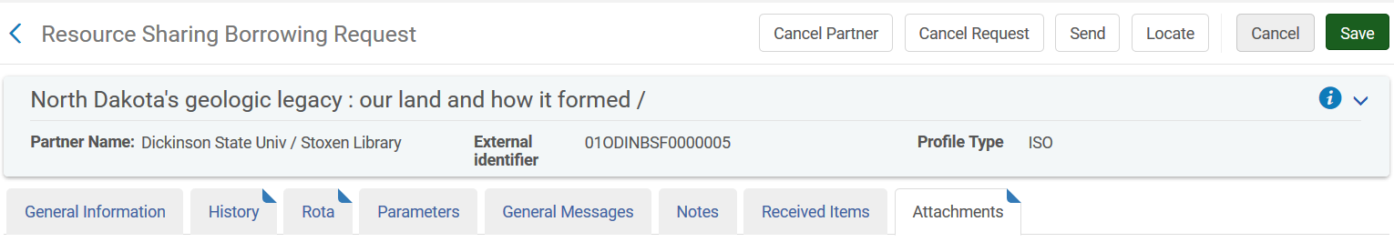

- Parameters
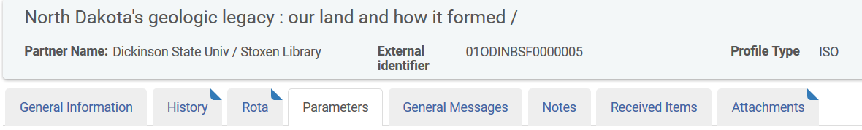
- General Messages. This tab displays messages that have been sent between the borrower and lender that pertain to the request. To send a message via the request, click the General Message button and fill out the displayed workform.
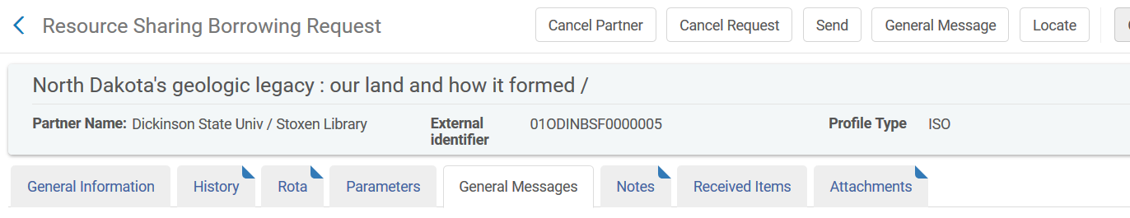

- Notes. This tab displays any notes associated with the request.
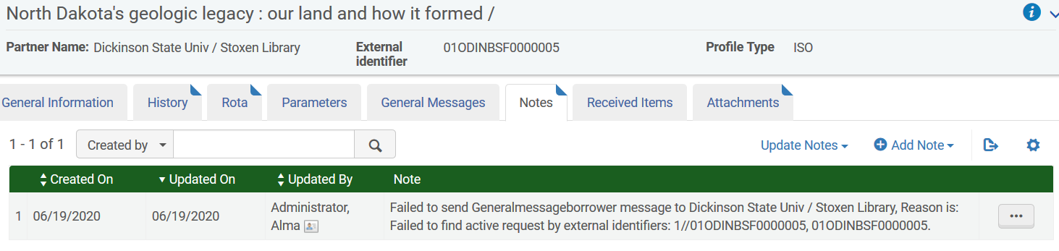

- Received items. Once the item has been received, the item(s) received display in this tab.
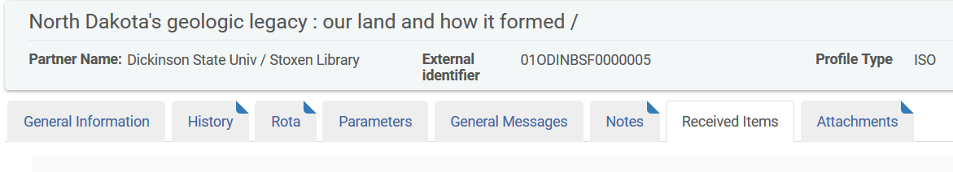
- Attachments. This tab displays any associated attachments.
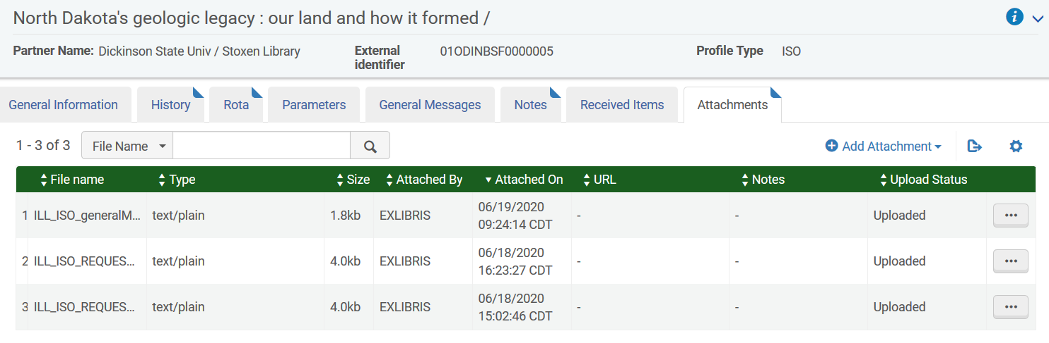
- Canceling requests.
It is possible to cancel requests that have not been shipped. With the request on the screen, click Cancel Request.
A workform displays allowing you to select a reason for the cancellation, an option to add a note as well as an opportunity to notify the user. Click Confirm to process the cancellation.
