Alma Fulfillment
Renewing Items

After logging into Alma, assure that you are ‘at’ your current Circulation Desk. To change locations, click the drop-down arrow next to your location to select another from the list.
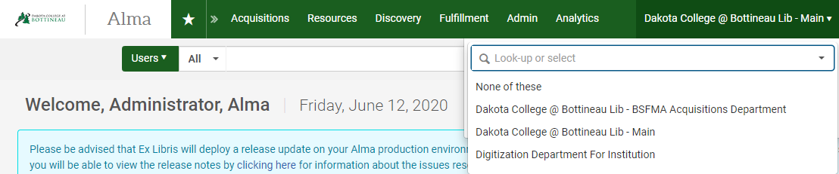

From the Fulfillment heading, select Manage Patron Services.
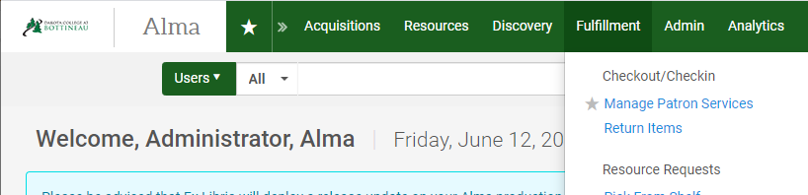

In the Patron Identification box that is displayed, scan the patron’s barcode, enter the patrons EMPL, or enter a portion of the patron’s name. The system will respond with auto-fill options – select the correct patron in this case to go to their record. Scanning the barcode or EMPL will take you directly to the record without a need to select from a drop-down menu.
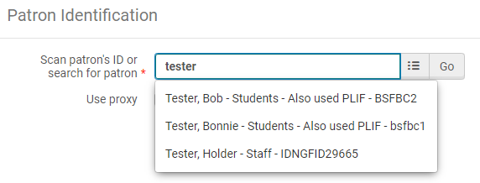

The patron management screen is displayed. There are four tabs available – Loans, Returns, Requests and Network Activity. With the Loans tab highlighted, change the Loan Display from Loans of this session to All Loans so everything the patron has checked out will display.
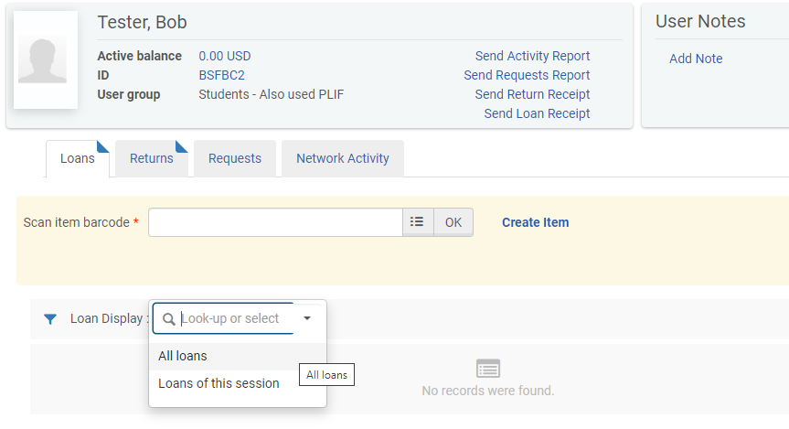

There are several options to renew loaned items. Check box(es) next to the item(s) to be renewed and click Renew Selected. If the patron wishes to renew everything, click Renew All. Alternatively, click the ellipse next to an individual loan and click Renew.
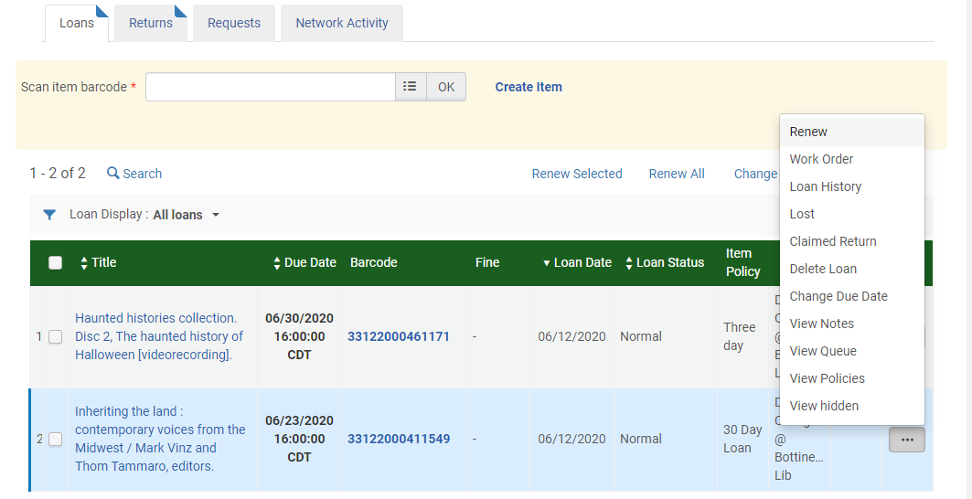
When renewing items, the system will automatically update the due date, if it is eligible to be renewed. A green display message appears in the upper right indicating the renewal was successful or a red display message appears indicating the renewal failed.
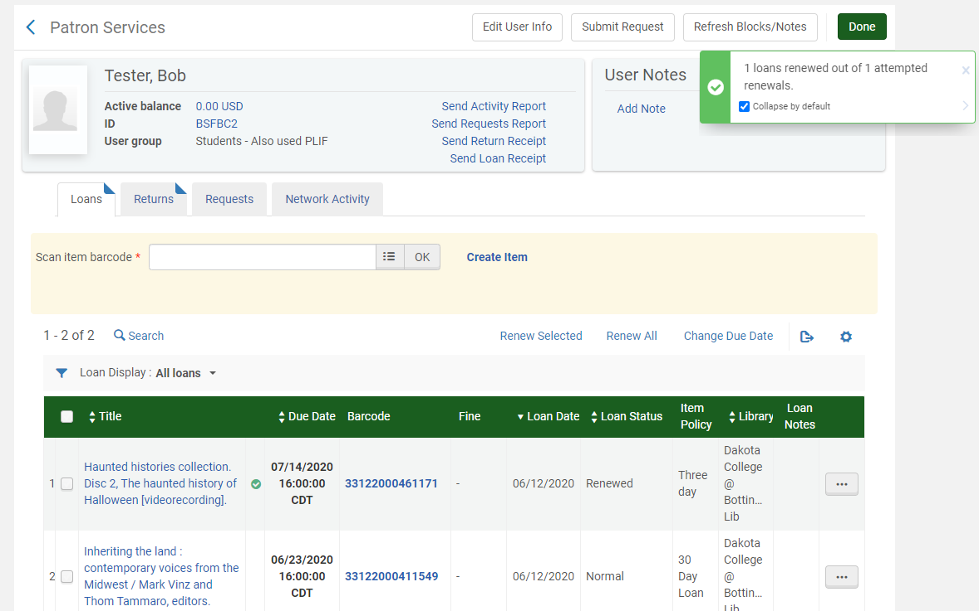

If the renewal fails, a red display message appears in the upper right. A red x appears next to the loan(s) where the renewal failed.

