ODIN – POLARIS
Loaning an Item

The Polaris LEAP interface is used for all circulation activity, including loaning material to patrons. https://polaris.odinlibrary.org/leapwebapp
To loan material to a patron, you must first retrieve the patron account. To retrieve a patron’s record, enter search criteria in the quick-search box. It is most effective to enter the barcode, but their name, email address, address or phone number can also be used.
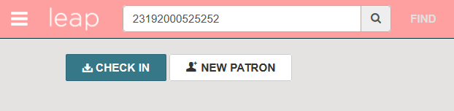

Alternatively, click to the FIND button to invoke the Find Tool. Here additional limiters can be used to search for and locate the patron record (please see the Polaris LEAP Overview document for tips on searching).
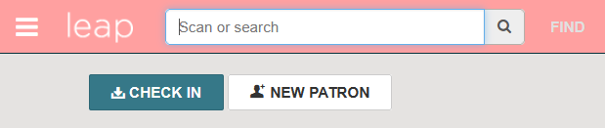

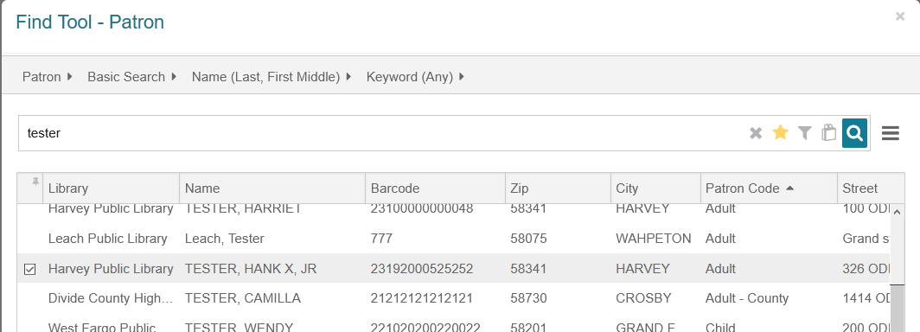

Once you’ve brought up the patron record, assure that the patron record belongs to your library.
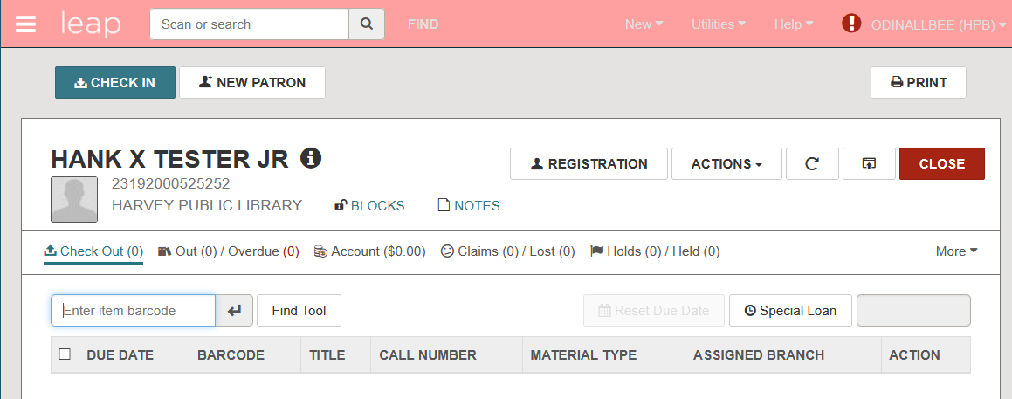

Note that the record default to Check Out. Scan (or type) the item barcode into the item barcode field. If you type the barcode, you will have to press enter to register the check-out.
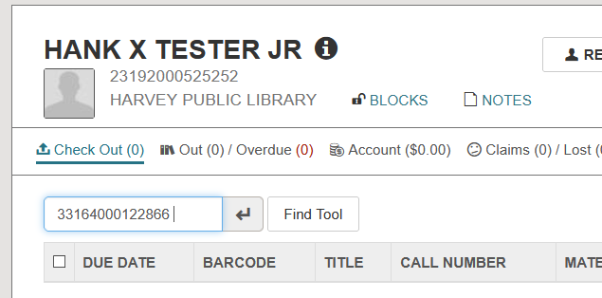

When the item is checked out, the due date, barcode and applicable bibliographic information will display. Continue to scan barcodes until all items have been checked out. Click COMPLETE to finalize the transaction. If you use a receipt printer, this will prompt the receipt to print.
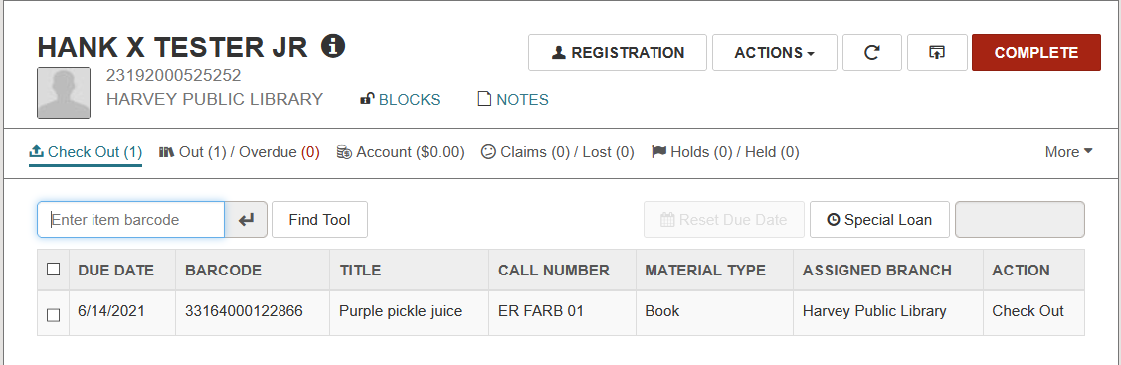
If necessary, it is possible to assign a different due date to items that have been loaned. When items are selected, the Reset Due Date button becomes active.
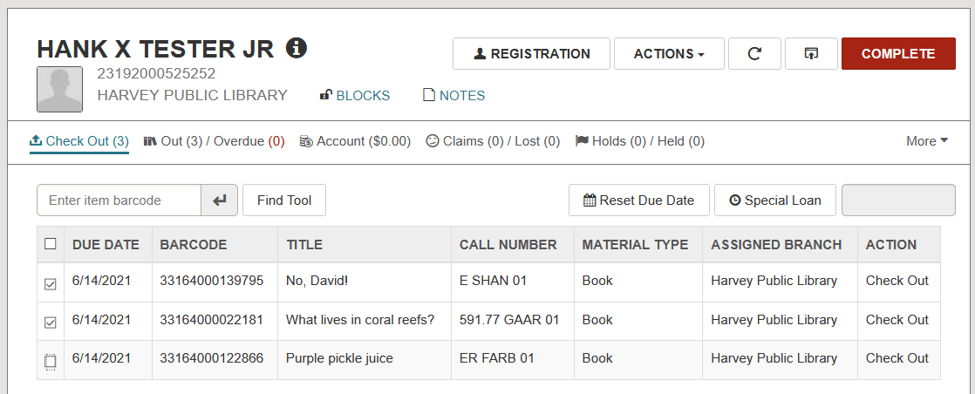

Click the Reset Due Date button and select a new due date. Use the calendar to select a new due date and click RESET DUE DATE. The dates of the loans will be changed.
