Alma Electronic Resources
Activating Aggregator Packages

- After assuring the resource isn’t already active for your library, in the Community Zone, locate the resource you wish to activate by conducting a search using the Electronic Collection limiter.
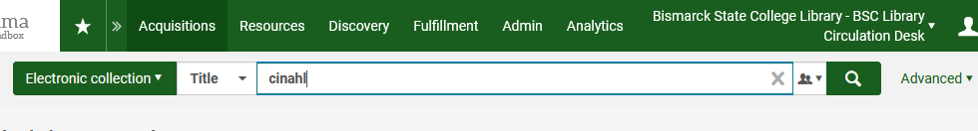
- In the list of results locate the resource to be activated. Once found, click Activate.
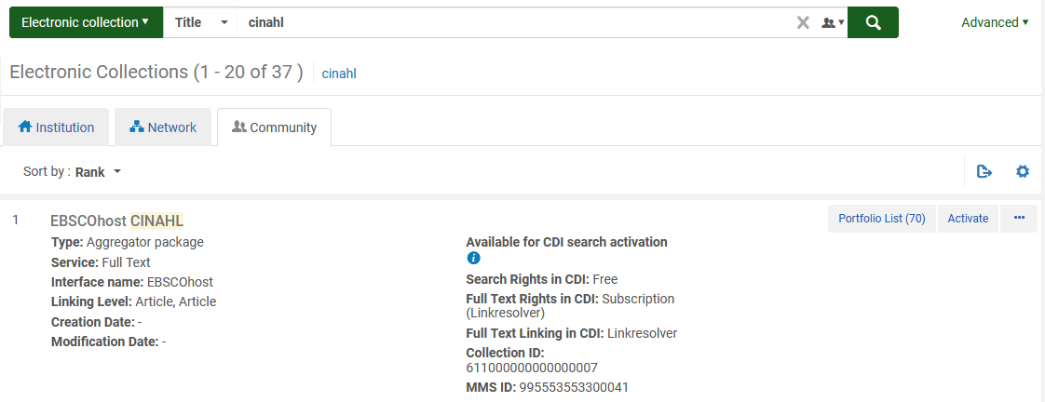

Note:
If the resource has the institution () zone or network () zone next to it, it has already been activated.

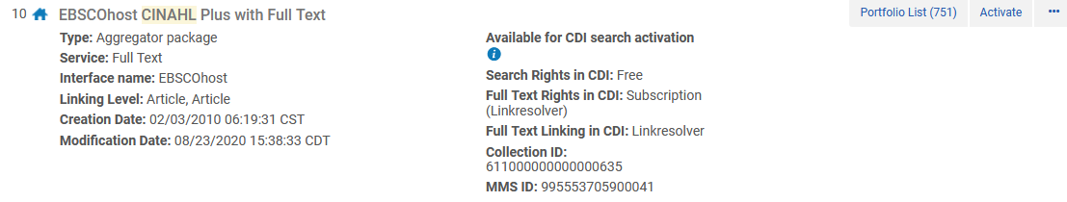

- The Activation Wizard displays. Depending on the responses to various fields of the wizard, the number of configuration screens may change as part of the wizard.
- Electronic Collection and Services Setup

- Local Electronic Collection Information – typically no changes will be needed in this section
- Public name
- Library
- Level URL
- Additional descriptive information – this information is automatically populated by Alma
- Mark Bib as suppressed – checked is the default. Leave this field as checked so the individual record for the collection (as a whole) will not be searchable
- Electronic Collection Proxy Enabled – no is the default. Leave this field as no as proxy information is handled on the portfolio level later in the wizard
- Electronic Collection Proxy Selected – do not select a proxy at this time – this will be done at the portfolio level later in the wizard.
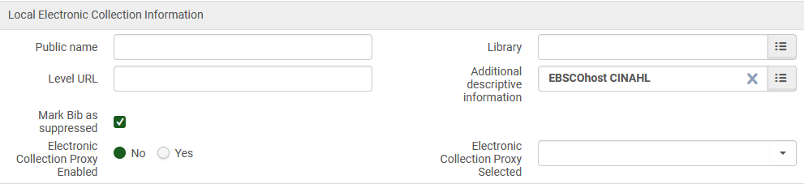

- Central Discover Index Information – typically no changes will be needed in this section

- CDI Search activation status – Active is the default. Leave this field set to Active so citations will be searchable in Primo.
- We subscribe to only some titles in this collection – Yes is the default. Leave this field set to Yes
- Do not show as Full Text available in CDI even if active in Alma – unchecked is the default.

- Full Text Service

- Activate this electronic collection service – check in order to activate the collection
- Make service available – check to make the collection available
- Automatically activate new portfolios – for aggregators, check to enable the system to automatically add new portfolios (titles) as they become available.
- Active from/until dates – use these fields to indicate start/until dates when activating trials. The fields are not needed for collections that have been purchased.
- Service public name
- Service Public Note
- Service Authentication Note
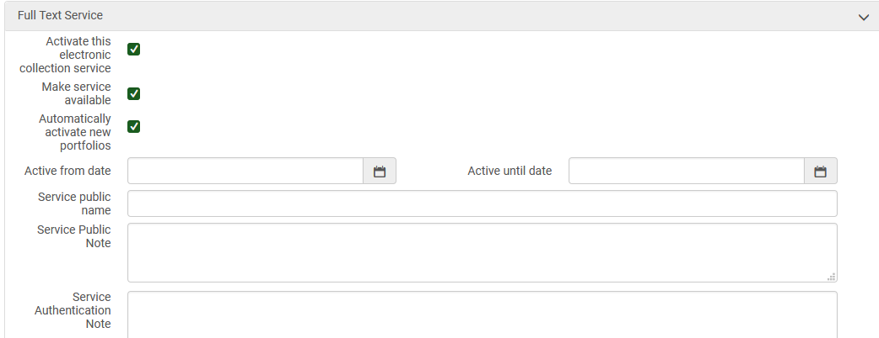
- Linking Information
- Parameter Name/Value – most collections won’t require this but if you are activating Gale (LOC_ID) or ProQuest (ClientID) collections, you will need to provide them.
- Full Text Service – Proxy setup – check Yes to enable the proxy and select Default from the proxy selected dropdown.
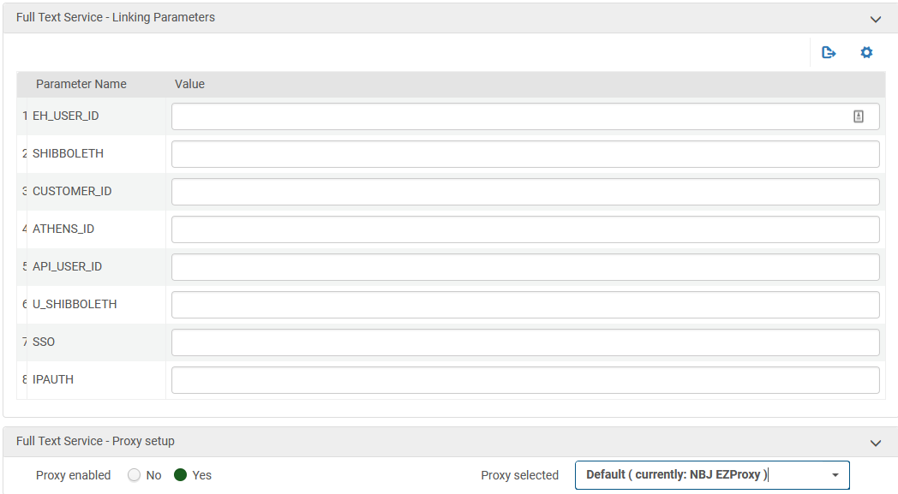
- Select Activation Method
- Activation type – select the applicable activation type. For aggregators, you will typically select activate all, as you’ve purchased the entire package.
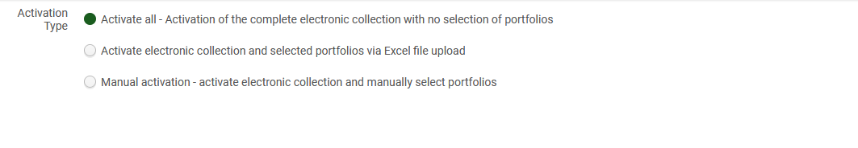
- Activation Summary
- A summary of what will be activated appears. Click Activate in order to begin the activation process.
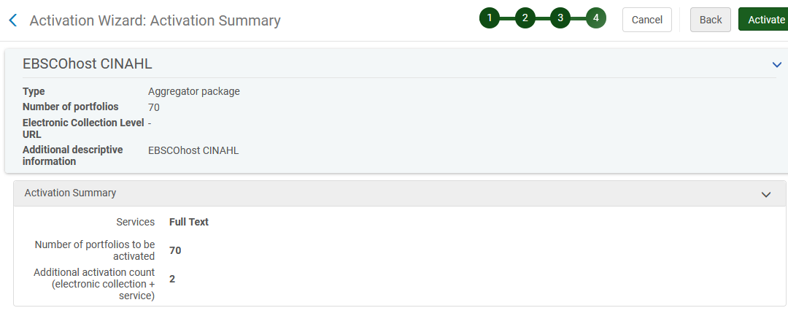

- Upon activating the collection, Alma will display a message if the activation was successful.
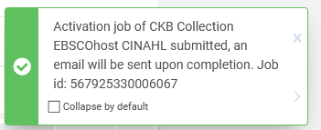

- It is possible to monitor the job as well by going to Admin | Manage Jobs and Sets | Monitor Jobs
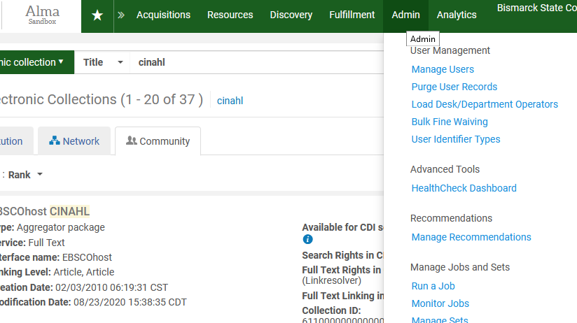
v

If a job is still running, it will be in the ‘Running’ tab – once it is complete you will find it in the History tab.
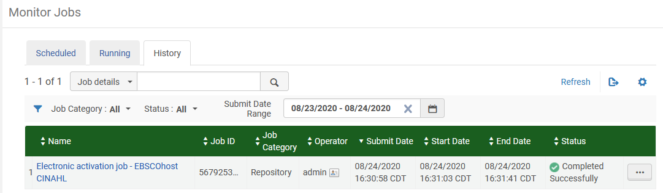
v

- Once the collection is active for your library, there will be an institution zone icon indicating as such.
v
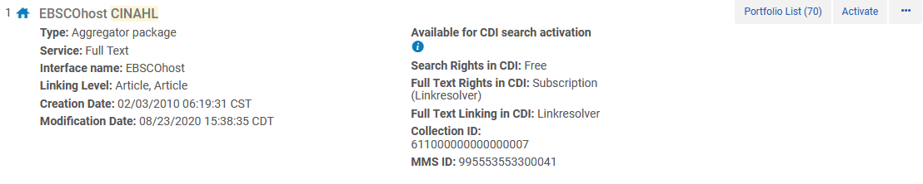
- In order to test that access is indeed working, search for a portfolio within the collection.
v
On the results screen, using the ellipse button next to the title select Test Access. Alternatively, click Edit Portfolio.
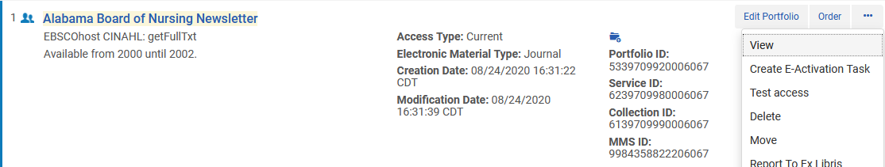
v
v

Edit portfolio will display the Electronic Portfolio Editor. Go to the Linking tab and click Test Access.
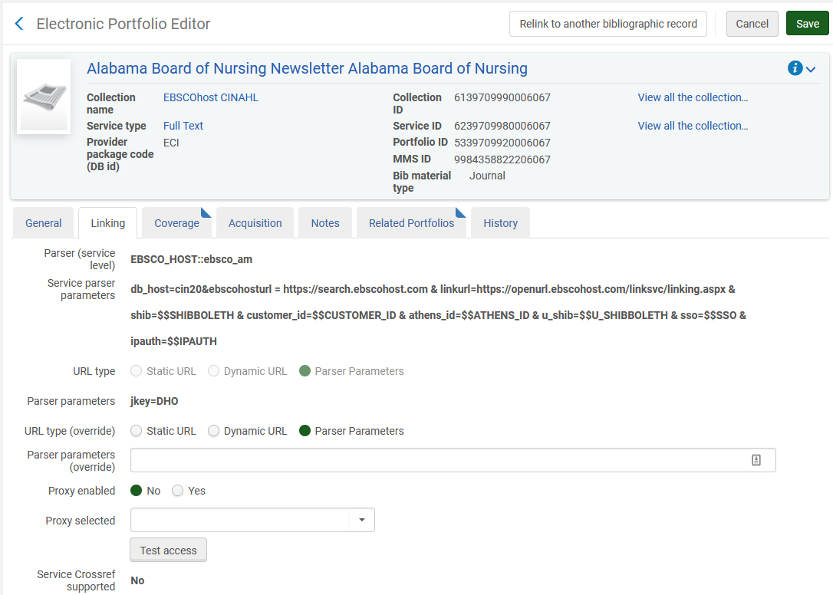
v
v
v

